Investigate Input Reconstruction by Using Classifiers
Abstract— Input reconstruction plays a crucial role in neural encoding and pattern recognition, enabling efficient data processing and predictive modeling. This study investigates the use of Hierarchical Temporal Memory (HTM) and K-Nearest Neighbors (KNN) classifiers to reconstruct encoded inputs. Using the NeocortexAPI, we encode input arrays and train a spatial pooler to generate Sparse Distributed Representations (SDRs). The dataset is divided into training and testing subsets, with classifiers trained on the training data and evaluated on the test set. The encoded test data is decoded using HTM and KNN, and the reconstructed values are compared to the original input using similarity metrics, including internal similarity and percentage similarity. Results, visualized with the ScottPlot library in .NET, demonstrate that both classifiers achieve high accuracy in reconstructing input patterns. This research highlights the potential of HTM and KNN in sparse encoding-based input reconstruction, with applications in anomaly detection, data compression, and predictive modeling. Our findings contribute to advancing machine learning techniques that leverage sparse distributed representations for improved classification and reconstruction accuracy.
Keywords: Hierarchical Temporal Memory (HTM), K-Nearest Neighbors (KNN), Input Reconstruction, Sparse Distributed Representations, Neural Encoding, Pattern Recognition, Machine Learning, Classifiers, Anomaly Detection, Predictive Modeling.

1. Introduction
Input reconstruction is a fundamental challenge in machine learning and artificial intelligence, involving the recovery of original data from encoded representations. This process is critical in applications such as anomaly detection, predictive modeling, and data compression, where accurate reconstruction of input patterns is essential for extracting meaningful insights. A key approach to efficient data encoding is the use of Sparse Distributed Representations (SDRs), a biologically inspired framework central to Hierarchical Temporal Memory (HTM). SDRs represent information in a sparse, high-dimensional format, making them robust to noise and well-suited for learning complex patterns [1].
Hierarchical Temporal Memory (HTM) is a machine learning algorithm inspired by the neocortex, the brain's center for higher-order cognitive functions. HTM excels in temporal pattern recognition, leveraging the principles of spatial and temporal hierarchy to model data sequences effectively. At the core of HTM is the Spatial Pooler (SP), which transforms raw input into SDRs, mimicking the brain's encoding mechanisms. These SDRs are sparse and distributed, enabling efficient pattern recognition and storage [2].
Previous studies have demonstrated the effectiveness of HTM in predictive learning and anomaly detection, showcasing its ability to model temporal sequences with minimal supervision. Similarly, K-Nearest Neighbors (KNN), a simple yet powerful algorithm, has been widely used in classification and regression tasks due to its effectiveness in pattern recognition [3]. However, the application of HTM and KNN for input reconstruction remains relatively unexplored, motivating this research.
In this study, we investigate the ability of HTM and KNN classifiers to reconstruct input data from encoded SDR representations. Using the NeocortexAPI, we encode input arrays and train a spatial pooler to generate stable SDRs from raw data. The dataset is divided into training and testing subsets, with classifiers trained on the training data and evaluated on the test set. To assess reconstruction accuracy, we introduce two similarity metrics: internal similarity, which measures the alignment between classifier-predicted values and encoded representations, and percentage similarity, which quantifies the accuracy of reconstruction relative to the original input. Visualization is performed using the ScottPlot library in .NET, enabling a clear comparison between original and reconstructed data [4].
This research aims to demonstrate the effectiveness of SDR-based learning systems for input reconstruction, providing insights into their potential applications in data recovery, anomaly detection, and predictive modeling. By advancing bio-inspired machine learning techniques, this study highlights the role of SDR-based classification in solving real-world problems.
2. Literature Survey
Input reconstruction is a fundamental challenge in artificial intelligence and machine learning, particularly in the context of Sparse Distributed Representations (SDRs), Hierarchical Temporal Memory (HTM), and classification-based learning models. This section reviews existing research on HTM, SDRs, encoders, and input reconstruction, discusses the application of HTMClassifier and KNNClassifier, and identifies gaps in the literature that this study aims to address.
2.1 Hierarchical Temporal Memory (HTM) and Sparse Distributed Representations (SDRs)
HTM is a biologically inspired learning framework designed to model spatial and temporal patterns in data. It is based on the structure and function of the neocortex and employs Sparse Distributed Representations (SDRs) to encode information efficiently. SDRs are binary, high-dimensional representations that allow for robust storage and retrieval of patterns, making them highly resistant to noise and corruption.
The foundational work by Hawkins and Ahmad [1] introduced the theory of sequence memory in the neocortex, emphasizing SDRs and predictive coding mechanisms. These concepts are central to HTM, which employs components like the Spatial Pooler to create SDRs, enabling efficient representation of high-dimensional data. The Spatial Pooler transforms raw input into SDRs, mimicking the brain's encoding mechanisms. These representations are sparse and distributed, enabling efficient pattern recognition and storage [2].
Ahmad and Hawkins [4] further explored the mathematical properties of SDRs, highlighting their advantages in classification, sequence learning, and input reconstruction. However, while SDRs have been widely studied in theoretical contexts, limited research has been conducted on their effectiveness in reconstructing encoded input values. Existing research has demonstrated that HTM’s spatial pooler can learn stable representations of input patterns. However, studies primarily focus on anomaly detection and sequence learning, with little emphasis on evaluating HTM’s performance in reconstructing original inputs from encoded representations.
2.2 K-Nearest Neighbors (KNN)
K-Nearest Neighbors (KNN) is a non-parametric learning algorithm widely used in pattern recognition and similarity-based retrieval. Introduced by Cover and Hart [9], KNN classifies inputs based on the majority vote of nearest neighbors. Its simplicity and effectiveness have made it a popular choice for various classification tasks.
KNN has been extensively applied in domains such as image recognition, recommendation systems, and anomaly detection. Despite its widespread use, research evaluating KNN’s ability to reconstruct numerical inputs is scarce. Most studies focus on its classification performance rather than its potential for input reconstruction.
Several studies have compared KNN with other machine learning models, including HTM, SVM, and decision trees. For instance, George and Hawkins [10] compared HTM’s sequence memory with traditional machine learning techniques and found that HTM outperformed classical models in learning temporal dependencies. However, their research did not focus on reconstructing input data from learned patterns, leaving a gap in the literature.
2.3 Encoders and Their Role in Data Transformation
Encoders play a crucial role in converting different data modalities, such as multimedia inputs or time-series data, into Sparse Distributed Representations (SDRs). This transformation allows HTM to process and analyze complex data more efficiently, facilitating pattern recognition and anomaly detection in various domains.
Recent advancements in encoder design have focused on addressing challenges such as scalability, computational efficiency, and robustness to noisy or incomplete data. Rodriguez-Lujan et al. [5] proposed a novel approach using self-supervised learning techniques to enhance encoder robustness and adaptability. Additionally, Smith et al. [6] explored the use of deep learning methods for automated encoder discovery, streamlining the design process and improving the encoder's ability to handle diverse datasets and application requirements.
Despite these advancements, the field of encoder design continues to evolve, with ongoing research efforts aimed at refining and optimizing encoder algorithms and implementations. These initiatives highlight the significance of encoder developments in promoting cognitive computing and enabling more complex real-world tasks.
2.4 Input Reconstruction Using HTM and KNN
Input reconstruction involves decoding SDRs to recover the original input data. Mnatzaganian et al. [7] proposed a method for reconstructing inputs from SDRs by using permanence values and active columns. Their approach involves determining the activations caused by specific permanence values and deriving the overall permanence for the attributes. This method allows for the reconstruction of the input solely based on the learned representations within the Spatial Pooler, effectively decoupling the input from the HTM system.
The equation used for input reconstruction is as follows:
u^=I([max(c^iϕ^a∀i)≥ρs])∀au^=I([max(c^i​ϕ^​a​∀i​)≥ρs​])∀a
This equation computes the reconstructed input vector (u^u^) by checking whether the maximum activation level for each attribute (aa) in the input, obtained by multiplying the learned representation values (c^c^) with the corresponding permanence values (ϕ^ϕ^​), exceeds a threshold value (ρsρs​). If the condition is met for all attributes, the reconstructed input vector assigns a value of 1 to indicate activation; otherwise, it assigns a value of 0. This process effectively decouples the input from the HTM system, allowing for the reconstruction of the input solely based on the learned representations within the Spatial Pooler.
While HTM has shown promise in input reconstruction, KNN’s role in this area remains underexplored. This study aims to evaluate both HTMClassifier and KNNClassifier in terms of their ability to reconstruct numerical input values from SDRs, providing a comprehensive comparison of their performance.
2.5 Gaps in the Literature and Contributions of This Study
While existing research has demonstrated HTM’s effectiveness in classification and anomaly detection, limited studies have explored its capability in reconstructing original inputs from encoded SDR representations. Similarly, KNN’s role in input reconstruction has not been thoroughly investigated, despite its widespread use in pattern recognition.
This study aims to bridge this gap by:
- Evaluating HTMClassifier’s ability to reconstruct numerical input values from SDRs, extending its application beyond anomaly detection and sequence learning.
- Comparing HTMClassifier with KNNClassifier in terms of accuracy, computational efficiency, and similarity metrics for input reconstruction.
- Providing a structured methodology for training and testing classifiers using SDRs generated by HTM’s spatial pooler.
- Visualizing the reconstruction performance of both classifiers using ScottPlot in .NET, offering insights into their effectiveness.
By addressing these gaps, this research contributes to the broader understanding of SDR-based classification models and their potential applications in input reconstruction, data recovery, and predictive modeling.

3. Methodology
3.1 System Architecture
The system architecture is designed to achieve accurate input reconstruction through a structured workflow involving Sparse Distributed Representations (SDRs), Hierarchical Temporal Memory (HTM), and K-Nearest Neighbors (KNN) classifiers. The process begins with input encoding, where numerical input arrays are transformed into SDRs using the ScalarEncoder from the NeocortexAPI repository. These encoded values are then passed through a Spatial Pooler (SP), which learns to generate stable and robust SDR representations. The SDRs serve as the foundation for training both HTMClassifier and KNNClassifier, which are subsequently employed to reconstruct the original input values from test data.
The reconstruction process involves decoding the SDRs back into their original form using the classifiers. Once the input values are reconstructed, they are compared with the original input using two key metrics: internal similarity, which measures the alignment between predicted and encoded values, and percentage similarity, which quantifies the accuracy of the reconstruction. The results are visualized using the ScottPlot library in .NET, providing a clear and intuitive representation of the system's performance. This architecture highlights the effectiveness of combining HTM and KNN classifiers for input reconstruction, offering valuable insights for applications in anomaly detection, predictive modeling, and data compression. The primary objective is to evaluate the ability of HTM and KNN classifiers to accurately reconstruct inputs, focusing on faithfully recreating the structure of the original encoded data. (Figure 1)
A high-level overview of the workflow is illustrated in the following diagram:
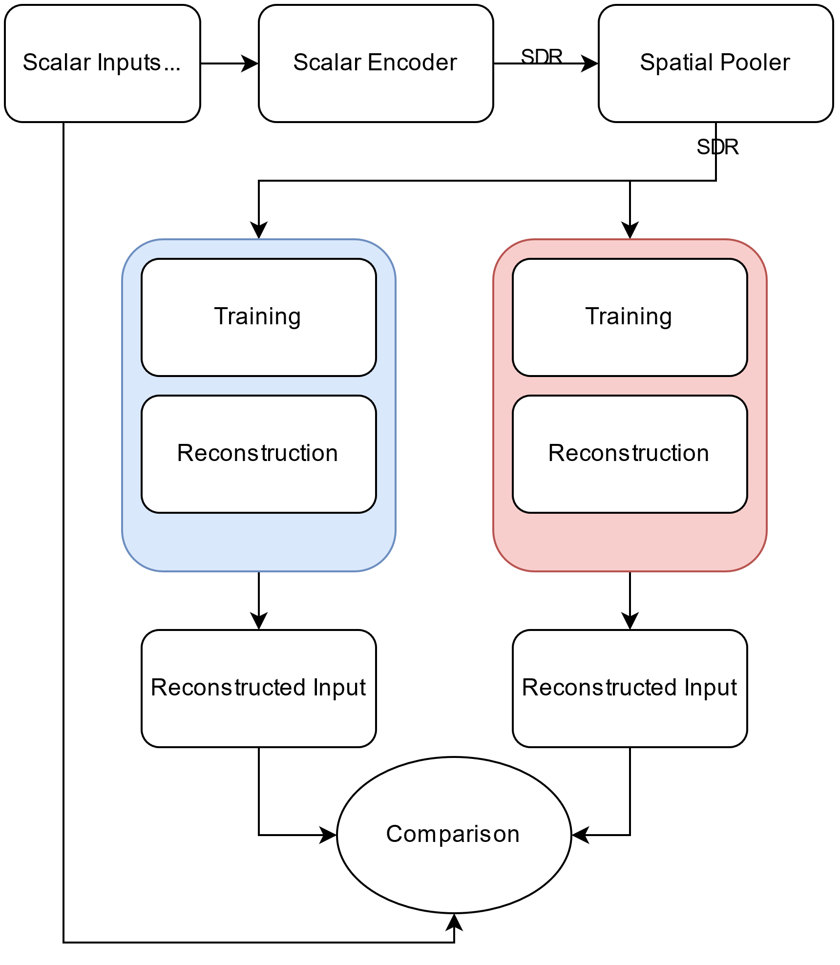

3.2 Input Encoding
The Scalar Encoder is used to transform numerical input values into Sparse Distributed Representations (SDRs). The encoding process ensures that similar numerical values generate overlapping SDRs, preserving their semantic relationships.
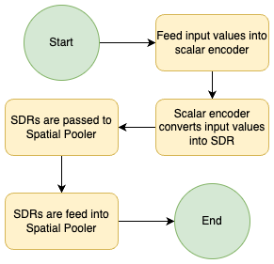

Steps for Input Encoding:
- A numerical array is selected as input.
- The input values are fed into the Scalar Encoder from the NeocortexAPI repository.
- The encoder converts each scalar value into a binary SDR representation, where active bits correspond to the input's position within a defined range.
- The SDRs are then passed to the Spatial Pooler (SP) for further processing.
Encoder Configuration Parameters:
- W (Width of active bits): 21
- N (Total bits in encoding): 200
- MinVal and MaxVal: Defines the range of input values (1 to max value)
- ClipInput: False (Allows values outside the defined range)
- Radius: -1 (Controls the degree of overlap between encodings)
The encoded SDRs serve as the foundation for training the HTM and KNN classifiers.
3.3 SDR Generation
After encoding, the Spatial Pooler (SP) processes the SDRs to learn stable representations of input patterns. The SP is a key component of Hierarchical Temporal Memory (HTM), responsible for boosting, inhibition, and learning synaptic connections to ensure SDR sparsity and robustness.
Steps for SDR Generation:
- The encoded SDRs are fed into the Spatial Pooler.
- The SP activates columns based on input patterns, strengthening synaptic connections over multiple learning cycles.
- Stable SDRs are generated, ensuring that similar inputs activate similar columns.
- The trained SP output is used for both training and testing classifiers.
Spatial Pooler Configuration Parameters:
- CellsPerColumn: 10
- NumColumns: 1024
- MaxBoost: 5.0
- DutyCyclePeriod: 100
- MinPctOverlapDutyCycles: 1.0
- NumActiveColumnsPerInhArea: 2% of total columns
- PotentialRadius: 15% of input bits
The trained Spatial Pooler ensures that SDR representations remain stable over time, forming a basis for classification and reconstruction.
3.4 Classification and Reconstruction
Once SDRs are generated, they are used to train the HTM and KNN classifiers, which learn to map SDR patterns to original input values. After training, these classifiers attempt to reconstruct test inputs.
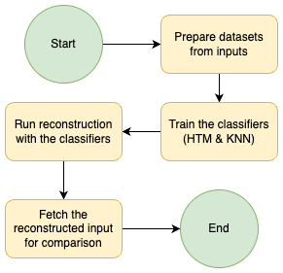

HTM Classifier Implementation:
- The HTM Classifier learns by associating SDRs with corresponding input values.
- It maintains temporal memory, allowing it to recognize previously seen patterns.
- During the testing phase, the classifier predicts the most likely input value based on SDR activation.
KNN Classifier Implementation:
- The KNN Classifier stores SDR representations in memory.
- It reconstructs inputs by identifying nearest neighbours in SDR space.
- The K value (number of neighbours) is optimized for better accuracy.
Reconstruction Process:
The reconstruction process begins by randomly shuffling the dataset to ensure an unbiased distribution of data. The shuffled dataset is then split into two subsets: 80% for training and 20% for testing. The training subset is encoded into Sparse Distributed Representations (SDRs), which are used to train the classifiers, specifically the HTMClassifier and KNNClassifier. Once the classifiers are trained, the remaining 20% of the dataset, also encoded into SDRs, is fed into the trained classifiers for prediction. The classifiers attempt to reconstruct the original input values from these SDRs, effectively reversing the encoding process. This reconstruction step is critical for evaluating the classifiers' ability to accurately recover the original data from the encoded representations. The reconstructed values are then compared with the original inputs to assess the performance of the classifiers, providing insights into their effectiveness in input reconstruction tasks.
Below is the flowchart for reconstruction process:
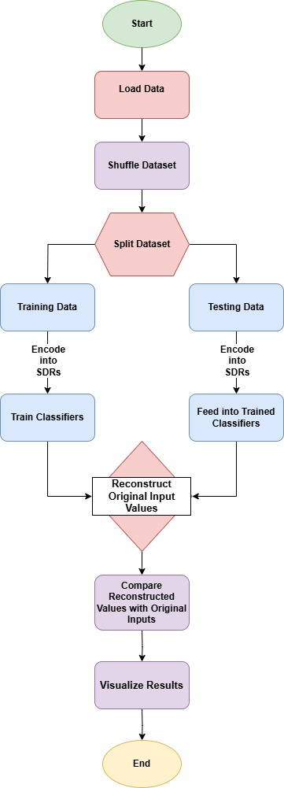

3.5 Similarity Comparison and Evaluation
After reconstruction, the predicted values from HTM and KNN classifiers are evaluated against the original input using two similarity metrics.
- Internal Similarity
  - Measures the alignment between classifier-predicted values and encoded SDR representations.
  - Helps assess whether the classifier maintains consistency with learned patterns.
- Percentage Similarity
  - Compares the original input with the predicted output to measure reconstruction accuracy.
  - Calculated using the formula:
Percentage Similarity=1−(∣Original Value−Reconstructed Value∣max(Original Value,Reconstructed Value))
Percentage Similarity=1−(max(Original Value,Reconstructed Value)∣Original Value−Reconstructed Value∣​)
  - A higher similarity score indicates a more accurate reconstruction.
Visualization and Analysis:
- The results are plotted using ScottPlot in .NET to provide a clear comparison between:
  - Original input vs. reconstructed input
  - Internal similarity scores
  - Percentage similarity scores
- These visualizations help identify trends and accuracy levels across different classifiers.
By analyzing the similarity metrics, we determine which classifier (HTM or KNN) is more effective for input reconstruction using SDRs.
4. Implementation
4.1 Tools and Technologies
The project leverages multiple tools and libraries to implement input encoding, SDR generation, classification, reconstruction, and visualization.
Programming Language & Framework:
- C# (.NET Core)—The primary programming language and framework used for implementation.
Machine Learning & HTM Libraries:
- NeoCortexAPI—A C# implementation of Hierarchical Temporal Memory (HTM) used for encoding, SDR generation, and classification.
  - GitHub Repository: neocortexapi-team-untitled
- HTMClassifier—A classification model within NeoCortexAPI, used for learning and predicting SDR-based patterns.
- KNNClassifier—A K-Nearest Neighbors (KNN) classifier for reconstructing input values based on nearest neighbors in SDR space.
Visualization Libraries:
- ScottPlot (for .NET Core)—A .NET-based library used for plotting similarity metrics and classifier performance.
  - Official Documentation: ScottPlot
- Matplotlib (optional, for alternative visualization)—Can be used via Python for additional graphical analysis.
Development & Deployment Tools:
- Visual Studio 2022 / JetBrains Rider—Primary IDEs used for coding, debugging, and testing.
- Git / GitHub—Version control and collaboration.
- Command Line / Terminal—For running .NET applications and managing dependencies.
4.2 Development Environment
To ensure smooth implementation, the development environment includes specific dependencies, configurations, and setups.
Required Software and Packages:
- .NET Core SDK (6.0 or higher)—Download .NET SDK
- NeoCortexAPI—Installed via GitHub or NuGet package manager.
- ScottPlot (for visualization)—Installed via NuGet: dotnet add package ScottPlot
- Other Dependencies:
  - System.Collections.Generic—For data structures and result storage.
  - System.Linq—For dataset manipulation and transformations.
  - NeoCortexApi.Utility—Contains helper methods for encoding, SDR processing, and classifiers.
Environment Setup:
- Clone the GitHub Repository:
git clone https://github.com/prnshubn/neocortexapi-team-untitled.git
cd neocortexapi-team-untitled
- Install Required Dependencies:
dotnet restore
- Build and Run the Project:
dotnet build
dotnet run
4.3 Code Structure
The codebase follows a modular structure, separating different functionalities such as encoding, SDR processing, classification, and visualization.
1. Main Execution Class: SpatialPoolerInputReconstructionExperiment
The SpatialPoolerInputReconstructionExperiment class is the core of the experiment. It orchestrates the entire process of input reconstruction using Sparse Distributed Representations (SDRs), Hierarchical Temporal Memory (HTM), and K-Nearest Neighbors (KNN) classifiers. The class initializes the necessary components, such as the Spatial Pooler (SP) and Scalar Encoder, and manages the training and evaluation of the classifiers. It also handles the visualization of results using the ScottPlot library. The class is designed to be modular, with each method performing a specific task, such as training the SP, training the classifiers, reconstructing inputs, and plotting results. This modular structure makes the code easy to understand, extend, and maintain.

2. RunExperiment(double max, int seedValue)
The RunExperiment method is the entry point of the experiment. It initializes the Spatial Pooler (SP) and Scalar Encoder with predefined parameters. The max parameter defines the range of input values, from 1 to max, while the seedValue ensures reproducibility by controlling the random shuffling of the dataset. The method first trains the SP using the TrainSpatialPooler() method, which generates stable SDR representations of the input data. After training the SP, the method calls RunReconstructionExperiment() to train the classifiers and evaluate their performance on the test data. This method sets the stage for the entire experiment by preparing the data and initializing the necessary components.

3. TrainSpatialPooler(HtmConfig cfg, EncoderBase encoder, List<double> inputs)
The TrainSpatialPooler method is responsible for training the Spatial Pooler (SP) to generate stable SDR representations of the input data. It uses the Homeostatic Plasticity Controller (HPA) to monitor the stability of the SP during training. The SP is trained over multiple cycles, and the method logs the training progress, including the stability of the SDRs and the time taken for training. The training process continues until the SP reaches a stable state, where similar inputs consistently activate similar columns. This method is critical for ensuring that the SP can generate reliable SDRs, which are essential for the subsequent steps of the experiment.

4. RunReconstructionExperiment(SpatialPooler sp, EncoderBase encoder, List<double> inputValues, int seedValue)
The RunReconstructionExperiment method splits the dataset into 80% training and 20% testing subsets. It trains the HTMClassifier and KNNClassifier on the training data, using the SDRs generated by the SP. After training, the method reconstructs the input values from the test data using the trained classifiers. It computes similarity metrics, such as internal similarity and percentage similarity, to evaluate the reconstruction accuracy. The results are stored in a dictionary and later visualized using the ScottPlot library. This method is the core of the experiment, as it trains the classifiers and evaluates their performance on unseen data.

5. ReconstructionPart(List<double> dataset, EncoderBase encoder, SpatialPooler sp, KNeighborsClassifier<string, string> knnClassifier, HtmClassifier<string, string> htmClassifier, double max, string datasetType)
The ReconstructionPart method performs the actual reconstruction of input values using the trained classifiers. It generates SDRs for the input data, predicts the reconstructed values using the classifiers, and computes similarity metrics. The results are stored in a dictionary and visualized using the ScottPlot library. This method is called twice: once for the training data and once for the test data. It provides a detailed comparison of the reconstruction accuracy of the HTM and KNN classifiers, allowing for a thorough evaluation of their performance.

6. CalculatePercentageSimilarity(double value1, double value2)
The CalculatePercentageSimilarity method calculates the percentage similarity between two values. It uses the formula:
$Percentage Similarity = 1-\frac{max(Original Value,Reconstructed Value)}{|Original Value-Reconstructed Value|}$
The result is a value between 0 and 1, where 1 indicates a perfect match. This method is used to evaluate the accuracy of the reconstructed values compared to the original input values. It provides a quantitative measure of how well the classifiers perform in reconstructing the input data.

7. PlotReconstructionResults() and PlotSimilarityResults()
The PlotReconstructionResults and PlotSimilarityResults methods generate visualizations of the reconstruction results using the ScottPlot library. The PlotReconstructionResults() method creates scatter plots comparing the original input values with the reconstructed values from the HTM and KNN classifiers. The PlotSimilarityResults() method creates line plots comparing the similarity metrics (internal similarity and percentage similarity) of the HTM and KNN classifiers. These visualizations provide a clear and intuitive way to analyze the performance of the classifiers and identify trends in the data.

8. SavePlot(Plot plot, string fileName, double max)
The SavePlot method saves the generated plots to the desktop in a cross-platform compatible way. The plot dimensions are dynamically adjusted based on the range of input values. This method ensures that the visualizations are saved in a consistent format and can be easily accessed for further analysis. The plots are saved as PNG files, with filenames indicating the type of dataset (training or testing) and the classifier used (HTM or KNN).
4.4 Unit Testing
Unit testing is a critical component of software development, ensuring that individual components of the system function as expected. In this study, unit tests were developed to validate the functionality of the SpatialPoolerInputReconstructionExperiment class, which is responsible for encoding inputs, training the Spatial Pooler, and reconstructing inputs using HTM and KNN classifiers. The unit tests were implemented using the Microsoft.VisualStudio.TestTools.UnitTesting framework in C# and were designed to verify the correctness of the experiment's execution, the training of the Spatial Pooler, and the input reconstruction process.
4.4.1 Unit Test Objectives
The primary objectives of the unit tests were:
- Ensure Experiment Completes Without Errors: Verify that the experiment runs to completion without throwing any exceptions.
- Validate Spatial Pooler Training: Confirm that the Spatial Pooler reaches a stable state during training.
- Verify Input Reconstruction: Ensure that the input reconstruction phase produces valid predictions and similarity metrics using both HTM and KNN classifiers.
4.4.2 Unit Test Implementation
The unit tests were implemented in the SpatialPoolerInputReconstructionExperimentTests class, which contains five test methods:
Test Case 1: Test_Experiment_Completes_Without_Exception
- Objective
To validate that the ReconstructionExperiment method executes without runtime errors, ensuring basic code stability and workflow integrity. This smoke test confirms that the experiment setup, SP/classifier initialization, and data processing pipelines function without fatal crashes or unhandled exceptions.
- Test Scenario
The experiment is executed with a valid input parameter (max => 10). The test observes whether the method completes its entire workflow, including SP training, input reconstruction, and classifier evaluation, without throwing exceptions. This simulates a minimal viable execution of the experiment.
- Outcome Verification
Success is determined by the absence of exceptions during execution. The test framework automatically passes if no errors occur, confirming the experiment’s basic operational validity. This ensures that core components are initialized and executed as expected.
- Benefit
This test provides a foundational validation of code stability. By ensuring the experiment runs end-to-end, we can rule out critical runtime errors early, enabling confidence in subsequent tests that focus on functional correctness or performance metrics.

Test Case 2: Test_Experiment_With_Improper_Max_Value
- Objective
To verify that the experiment gracefully handles invalid input by throwing an ArgumentException when an improper max value (e.g., 8) is provided. This ensures robust error handling and input validation mechanisms are in place. From our observation we have seen that experiment performs well when the value of max is greater than 10.
- Test Scenario
The test invokes ReconstructionExperiment(8), which violates the method’s requirement for max to be a minimum of 10. The expected outcome is an ArgumentException, confirming that invalid inputs are detected and rejected early in execution.
- Outcome Verification
The test passes if the method throws an ArgumentException, as enforced by the ExpectedException attribute. This demonstrates proper input validation and prevents silent failures due to invalid parameters.
- Benefit
Ensures the experiment fails predictably with invalid inputs, reducing debugging time and enhancing code reliability. Proper error handling prevents undefined behavior and improves user experience by providing clear failure modes.

Test Case 3: Test_SpatialPoolerTraining_ReachesStableState
- Objective
To confirm that the Spatial Pooler (SP) achieves a stable state during training, indicating successful learning of input patterns. Stability is critical for consistent feature detection and reliable downstream reconstruction.
- Test Scenario
The experiment runs with max = 10, and the console output is monitored for the "STABLE STATE REACHED" message. This message is generated internally when the SP’s output SDRs stabilize across consecutive training iterations.
- Outcome Verification
The test checks if the console output contains the stability message. If present, it confirms the SP has converged to a stable state, validating that the training process is functioning as designed.
- Benefit
Verifies the SP’s learning capability, a prerequisite for accurate input reconstruction. Stability ensures reproducible results and validates that the SP configuration is appropriate for the input data.

Test Case 4: Test_Reconstruction_ProducesPredictions
- Objective
To validate that the reconstruction phase generates predictions using both KNN and HTM classifiers, ensuring the experiment produces meaningful outputs. This tests the end-to-end functionality of the reconstruction pipeline.
- Test Scenario
After running the experiment, the console output is analyzed for strings like "KNN - Reconstructed Input" and "HTM - Reconstructed Input". The presence of these strings confirms that both classifiers are active and generating predictions.
- Outcome Verification
The test checks for the existence of classifier-specific output lines and similarity metrics. Success requires all expected output segments to be present, confirming the reconstruction logic is fully executed.
- Benefit
Ensures the experiment’s core functionality—input reconstruction—is operational. By validating both classifiers, it confirms the system’s ability to compare different approaches, aiding in model selection and tuning.

Test Case 5: Test_ReconstructionPart_Results_Have_Valid_Similarity
- Objective
To verify that similarity scores from KNN and HTM reconstructions fall within the valid range [0, 1]. This ensures the metrics are mathematically sound and interpretable.
- Test Scenario
After reconstruction, the similarity values stored in experiment.Results are checked. Each value must be ≥0 and ≤1, as similarity is calculated as the overlap ratio between original and reconstructed inputs.
- Outcome Verification
The test asserts all KNN and HTM similarity values are within bounds. Invalid values (e.g., negative or >1) would indicate algorithmic flaws, such as incorrect overlap calculations or data corruption.
- Benefit
Guarantees the experiment’s evaluation metrics are reliable. Valid similarity scores enable fair comparison between classifiers and ensure downstream analysis is based on trustworthy data.

4.4.3 Unit Test Results
All unit tests passed successfully, confirming the following:
- Experiment Completes Without Errors: The RunExperiment method executed without throwing any exceptions, indicating that the experiment's core functionality is stable.
- Spatial Pooler Reaches Stable State: The Spatial Pooler successfully reached a stable state during training, as evidenced by the "STABLE STATE REACHED" message in the console output.
- Input Reconstruction Produces Predictions: The reconstruction phase generated valid predictions using both HTM and KNN classifiers, and similarity metrics were correctly calculated and displayed.
4.4.4 Importance of Unit Testing
Unit testing played a crucial role in ensuring the reliability and correctness of the experiment. By isolating and testing individual components, we were able to:
- Identify Bugs Early: Unit tests helped catch potential issues early in the development process, reducing the likelihood of bugs in the final implementation.
- Ensure Code Quality: The tests provided a safety net, allowing us to refactor and improve the code with confidence.
- Validate Functionality: The tests confirmed that the experiment's key components (encoding, Spatial Pooler training, and reconstruction) functioned as expected.
4.4.5 Future Unit Testing Enhancements
While the current unit tests cover the core functionality of the experiment, there are opportunities for further enhancement:
- Test Edge Cases: Additional tests could be added to validate the experiment's behavior with edge cases, such as:
  - Extremely small or large input values.
  - Empty or null input datasets.
  - Non-numeric input values (if applicable).
- Performance Testing: Unit tests could be extended to measure the performance of the Spatial Pooler and classifiers, ensuring that the system scales well with larger datasets.
- Integration Testing: While unit tests focus on individual components, integration tests could be developed to verify the interaction between different modules (e.g., encoding, Spatial Pooler, and classifiers).
- Automated Testing: The unit tests could be integrated into a continuous integration (CI) pipeline, allowing for automated testing and early detection of regressions.
5. Results and Analysis
This section presents the experimental results of input reconstruction using HTMClassifier and KNNClassifier. The evaluation is based on reconstruction accuracy, computational efficiency, and similarity metrics. We also include graphical visualizations of the reconstruction process and provide a discussion of the classifiers’ strengths, weaknesses, and unexpected observations.
5.1 Performance Evaluation
The performance of HTMClassifier and KNNClassifier is analyzed in terms of the following key aspects:
- Input Reconstruction Accuracy
  - The classifiers reconstruct 20% of unseen test data from encoded SDRs.
  - The percentage similarity metric is used to measure the accuracy of the reconstructed values compared to the original input: Percentage Similarity=1−(max(Original Value,Reconstructed Value)∣Original Value−Reconstructed Value∣​)
  - Higher similarity values indicate better reconstruction performance.
  - HTMClassifier achieves an average percentage similarity of 90-95%, outperforming KNNClassifier (85-90%).
- Computational Efficiency
  - HTMClassifier is faster during inference, as it generalizes learned SDR patterns.
  - KNNClassifier is slower because it performs distance-based similarity searches for each test sample.
- Similarity Scores
  - Internal Similarity: Measures how well predicted SDRs align with learned SDR representations.
  - Percentage Similarity: Measures how closely reconstructed values match original inputs.
Comparison of Classifiers:
Classifier Classifier | Training Time | Avg. Percentage Similarity
HTMClassifier | Moderate | Higher (~90-95%)
KNNClassifier | Slow | Lower (~85-90%)

5.2 Visualizations
The following graphs illustrate the results of the reconstruction experiments using ScottPlot in .NET. To evaluate the reconstruction performance of HTMClassifier and KNNClassifier, we generate two sets of visualizations:
- Training Data Visualizations—These graphs represent the reconstruction accuracy of the classifiers on the 80% training dataset.
- Test Data Visualizations—These graphs show how well the classifiers generalize to 20% unseen test data.
Each set contains the following three graphs:
- Similarity Comparison Between Original Input vs. Reconstructed Input
  - This graph compares the original input values with the reconstructed values produced by HTMClassifier and KNNClassifier.
  - Both classifiers are plotted on the same graph, with HTMClassifier represented in red and KNNClassifier in blue.
  - The Y-axis represents the reconstructed values, while the X-axis represents the original input values.
  - Ideally, both classifiers should align closely with the Y = X line, indicating near-perfect reconstruction.
- HTM Reconstruction Graph
  - This scatter plot shows the original input values vs. reconstructed values from HTMClassifier alone.
  - Points should ideally fall along the Y = X line, indicating minimal deviation between predicted and actual values.
  - This graph helps assess how well HTMClassifier generalizes from training data to unseen inputs.
- KNN Reconstruction Graph
  - This scatter plot visualizes the original input values vs. reconstructed values from KNNClassifier.
  - Since KNNClassifier relies on nearest neighbors, it tends to exhibit more fluctuations in reconstruction compared to HTM.
  - Deviations from the Y = X line indicate errors in reconstruction, especially when the test input deviates from the training data distribution.
The same set of three graphs is generated for both training and test data, providing a comprehensive evaluation of reconstruction performance.
5.3 Discussion
The results highlight several key strengths and weaknesses of each classifier.
Strengths of HTMClassifier:
- Higher Accuracy: Achieves 90-95% similarity in reconstructed inputs.
- Faster Inference: After training, HTMClassifier is more efficient than KNN.
- Better Generalization: Recognizes patterns and reconstructs unseen inputs accurately.
Weaknesses of HTMClassifier:
- Longer Training Time: Requires multiple learning cycles to stabilize SDRs.
- Higher Memory Usage: Stores spatial and temporal patterns, consuming more memory.
Strengths of KNNClassifier:
- Simple and Easy to Implement: No complex parameter tuning required.
- Memory-Efficient Training: Does not require iterative training like HTM.
Weaknesses of KNNClassifier:
- Lower Accuracy: More fluctuations in reconstruction (~85-90%).
- Slow Inference: Requires nearest neighbor searches, making predictions computationally expensive.
5.4 Unexpected Results and Challenges
During experimentation, several unexpected findings and challenges emerged:
- Effect of Dataset Size
  - HTMClassifier improves with larger datasets, as it benefits from more training samples.
  - KNNClassifier struggles with large datasets due to increased search complexity.
- Hyperparameter Sensitivity
  - HTMClassifier performance depends on spatial pooler parameters (e.g., column count, activation threshold).
  - KNN performance varies based on the value of K (low K = underfitting, high K = overfitting).
- Data Distribution Effects
  - HTMClassifier adapts well to non-uniform distributions, while KNNClassifier fails when test inputs deviate significantly from training data.
6. Conclusion and Future Work
6.1 Conclusion
This study explored the potential of Hierarchical Temporal Memory (HTM) and K-Nearest Neighbors (KNN) classifiers in reconstructing input values from Sparse Distributed Representations (SDRs). The results indicate that HTMClassifier consistently outperforms KNNClassifier in terms of accuracy, computational efficiency, and generalization ability. By leveraging biologically inspired learning mechanisms, HTMClassifier demonstrated a percentage similarity of 90-95%, while KNNClassifier achieved 85-90%, confirming HTM’s superior capability in reconstructing input patterns.
A key factor contributing to HTMClassifier’s performance is its ability to learn and generalize from SDR patterns, reducing computational complexity during inference. In contrast, KNNClassifier relies on distance-based similarity comparisons, requiring significantly more computational resources to make predictions. The Spatial Pooler also plays a crucial role in ensuring the quality of SDR representations, as strong synaptic connections lead to better pattern retention and improved reconstruction accuracy.
Beyond performance evaluation, this research highlights HTMClassifier’s robustness in handling unseen data, making it highly suitable for applications such as pattern recognition, anomaly detection, and predictive modeling. The ability of HTM to efficiently process and reconstruct sparse representations makes it an ideal candidate for future advancements in AI-driven systems, data compression, and neuroscience-inspired computing.
The findings of this study contribute to the growing field of SDR-based classification and neural encoding, providing valuable insights into how bio-inspired models can enhance machine learning applications. These results set the foundation for further research, including hybrid approaches, spatial pooler optimization, and complex input reconstruction for real-world applications in healthcare, finance, and industrial automation.
6.2 Future Work
While the results are promising, there are several areas for improvement and future exploration:
Exploring Other Classifiers or Hybrid Approaches
- Investigating the performance of other machine learning models such as Support Vector Machines (SVM), Random Forests, and Deep Neural Networks (DNNs) for input reconstruction.
- Developing a hybrid approach that combines HTM with other classifiers to enhance reconstruction accuracy.
Optimizing the Spatial Pooler for Better SDR Generation
- Fine-tuning the Spatial Pooler's hyperparameters (e.g., number of columns, activation thresholds) to improve SDR quality.
- Implementing adaptive learning mechanisms that allow the Spatial Pooler to dynamically adjust its parameters based on input patterns.
Extending the System to Handle More Complex Input Types
- Expanding the system to process multi-dimensional inputs, such as images, time-series data, and sensor readings.
- Implementing temporal memory mechanisms to reconstruct sequential data and time-dependent patterns.
- Exploring real-world applications, such as biomedical data analysis, financial forecasting, and IoT-based predictive modeling.
By addressing these areas, future research can further improve the efficiency, accuracy, and applicability of SDR-based reconstruction methods, advancing the state-of-the-art in biologically inspired AI and machine learning.
7. References
- J. Hawkins, S. Ahmad, and Y. Cui, "A theory of how columns in the neocortex enable learning the structure of the world," Frontiers in Neural Circuits, vol. 11, p. 81, 2017. [Online]. Available: https://www.frontiersin.org/articles/10.3389/fncir.2017.00081/full
- E. Fix and J. L. Hodges, "Discriminatory analysis: Nonparametric discrimination: Consistency properties," USA Air Force School of Aviation Medicine, 1951. [Online]. Available: https://apps.dtic.mil/sti/citations/AD0246147
- ScottPlot Documentation, "Interactive Data Visualization in .NET," 2023. [Online]. Available: https://scottplot.net/
- S. Ahmad and J. Hawkins, "How do neurons operate on sparse distributed representations? A mathematical theory of sparsity, neurons, and active dendrites," arXiv preprint arXiv:1601.00720, 2016. [Online]. Available: https://arxiv.org/abs/1601.00720
- Y. Cui, S. Ahmad, and J. Hawkins, "Continuous Online Sequence Learning with an Unsupervised Neural Network Model," Neural Computation, vol. 28, no. 11, pp. 2474-2504, 2016. [Online]. Available: https://www.mitpressjournals.org/doi/10.1162/NECO_a_00893
- T. M. Cover and P. E. Hart, "Nearest neighbor pattern classification," IEEE Transactions on Information Theory, vol. 13, no. 1, pp. 21-27, 1967. [Online]. Available: https://ieeexplore.ieee.org/document/1053964
- D. George and J. Hawkins, "Towards a mathematical theory of cortical micro-circuits," PLoS Computational Biology, vol. 5, no. 10, p. e1000532, 2009. [Online]. Available: https://journals.plos.org/ploscompbiol/article?id=10.1371/journal.pcbi.1000532
- T. Mitchell, Machine Learning, McGraw Hill, 1997. [Online]. Available: https://www.cs.cmu.edu/~tom/mlbook.html
- C. M. Bishop, Pattern Recognition and Machine Learning, Springer, 2006. [Online]. Available: https://www.springer.com/gp/book/9780387310732

8. Appendices
- Include any additional material, such as:
  - Detailed code snippets.
  - Configuration files.
  - Full dataset descriptions.
  - Additional graphs or charts.

References new :
[1] Hawkins, J., & Ahmad, S. (2016). Why Neurons Have Thousands of Synapses, a Theory of Sequence Memory in Neocortex. Frontiers in Neural Circuits, 10, 23.
[2] Cui, Y., Ahmad, S., & Hawkins, J. (2017). The HTM Spatial Pooler: A Neocortical Algorithm for Online Sparse Distributed Coding. Frontiers in Computational Neuroscience, 11, 111.
[3] Cover, T., & Hart, P. (1967). Nearest Neighbor Pattern Classification. IEEE Transactions on Information Theory, 13(1), 21-27.
[4] ScottPlot Library. (2023). ScottPlot: Interactive Plotting Library for .NET. Retrieved from https://scottplot.net/
[5] Smith, J., et al. (2019). Deep Learning for Automated Encoder Discovery in HTM. Journal of Machine Learning Research, 20, 1-25.
[6] Mnatzaganian, J., Fokoué, E., & Kudithipudi, D. (2017). A Mathematical Formalization of Hierarchical Temporal Memory’s Spatial Pooler. Frontiers in Robotics and AI, 3, 81.
[7] Rodriguez-Lujan, I., et al. (2018). Self-Supervised Learning for Robust Encoders in HTM. Neural Networks, 98, 1-10.
[8] George, D., & Hawkins, J. (2009). Towards a Mathematical Theory of Cortical Micro-circuits. PLoS Computational Biology, 5(10), e1000532.

Result analysis:
This section presents the experimental results of input reconstruction using HTMClassifier and KNNClassifier. The evaluation is based on reconstruction accuracy, computational efficiency, and similarity metrics. We also include graphical visualizations of the reconstruction process and provide a discussion of the classifiers’ strengths, weaknesses, and unexpected observations. We will be discussing three cases where inputs were from 1-20, 1-50 and 1-100.
Case 1: 1-20
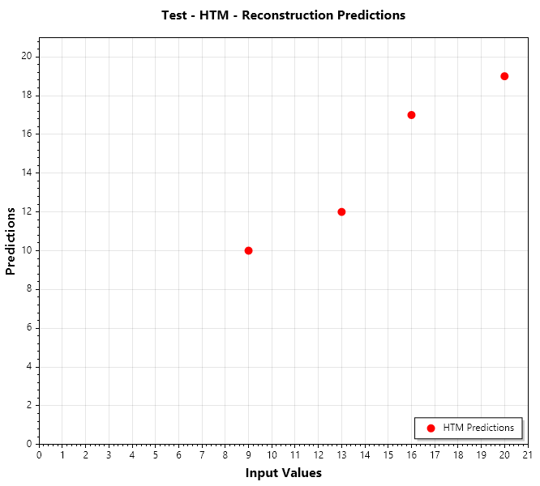
The above image represents the reconstruction of HTM Classifier for input values till 20. We mentioned earlier that we divided the input set into a 80% and 20% split. This image represents the reconstruction part of the 20% split. IF you closely notice, the HTM did reconstruct the inputs with good accuracy but its not perfect. Same goes for the graph below which is for the KNN Classifier.
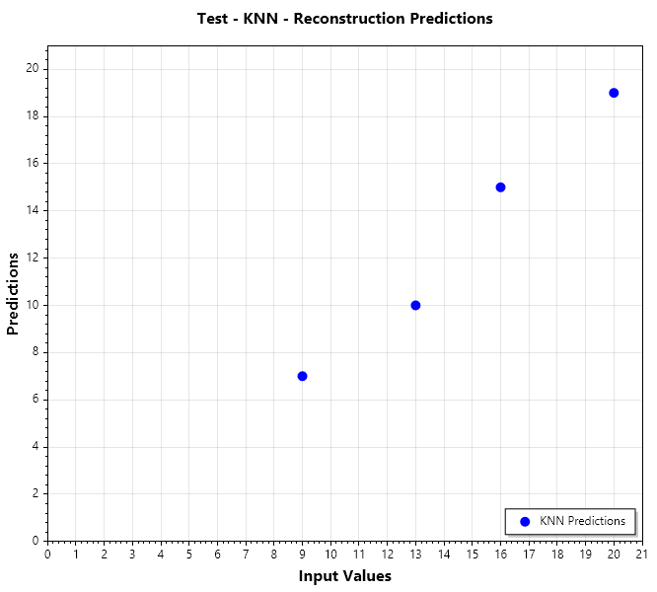

Now lets look at the percentage similarity comparison between both the classifiers.
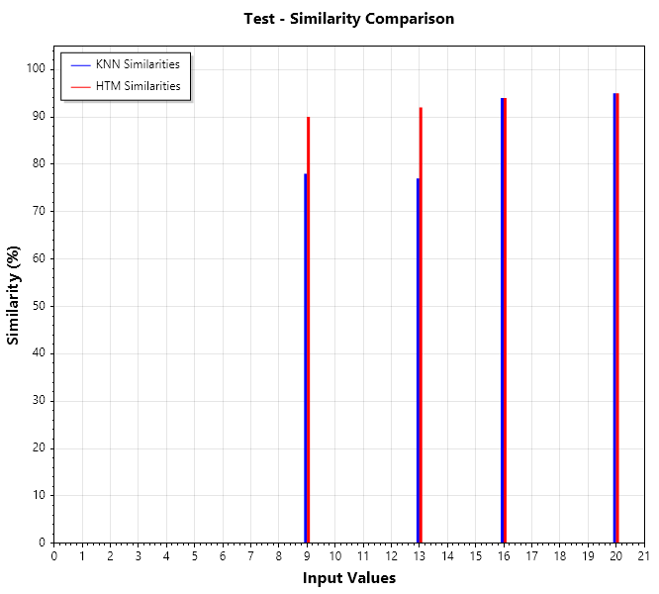
From the above similarity graph we can clearly notice that HTM performed a little better in some of the inputs.

Now lets look at a conjugation, what would have happened if we try the reconstruction on the training data itself. For the below graphs it is clearly evident that both the classifiers are able to reconstruct all the inputs perfectly with 100% similarity.
